Assignment on

Internet Technologies

Assignment Weightage & Type

60% Portfolio Coursework

Corse: BSc (Hons) CS & DF

Sem_2

UWE ID: 24030171

Student Name: MD Faisal

Assignment Date: Week_4

Design the below like wireframe structure. Use your own creativity.

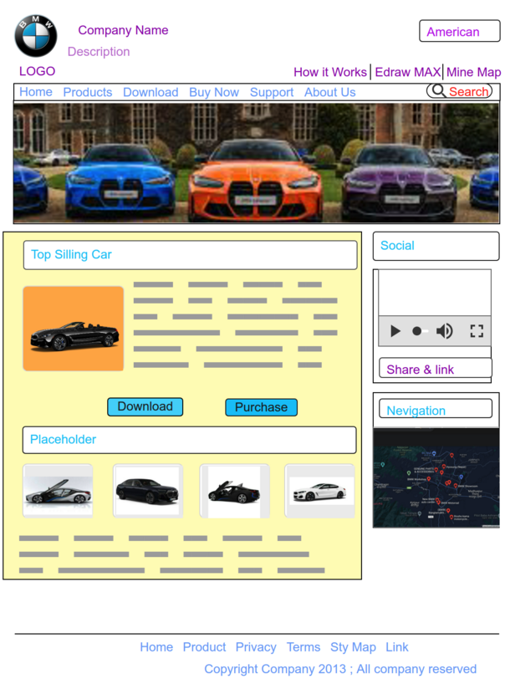

Create a mockup design like your college website’s contact us page. Use your own creativity for this design.

